**Boosting Algorithm**

The boosting algorithm assigns equal weight to each data sample. It feeds the data to the first machine model, called the base algorithm. The base algorithm makes predictions for each data sample.

**1. Ada Boost**

Ada Boost also called as (Adaptive Boosting) regressoris a meta-estimator that begins by fitting a regressor on the original dataset and then fits additional copies of the regressor on the same dataset but where the weights of instances are adjusted according to the error of the current prediction. It working like tree based on the error it will create next new model.

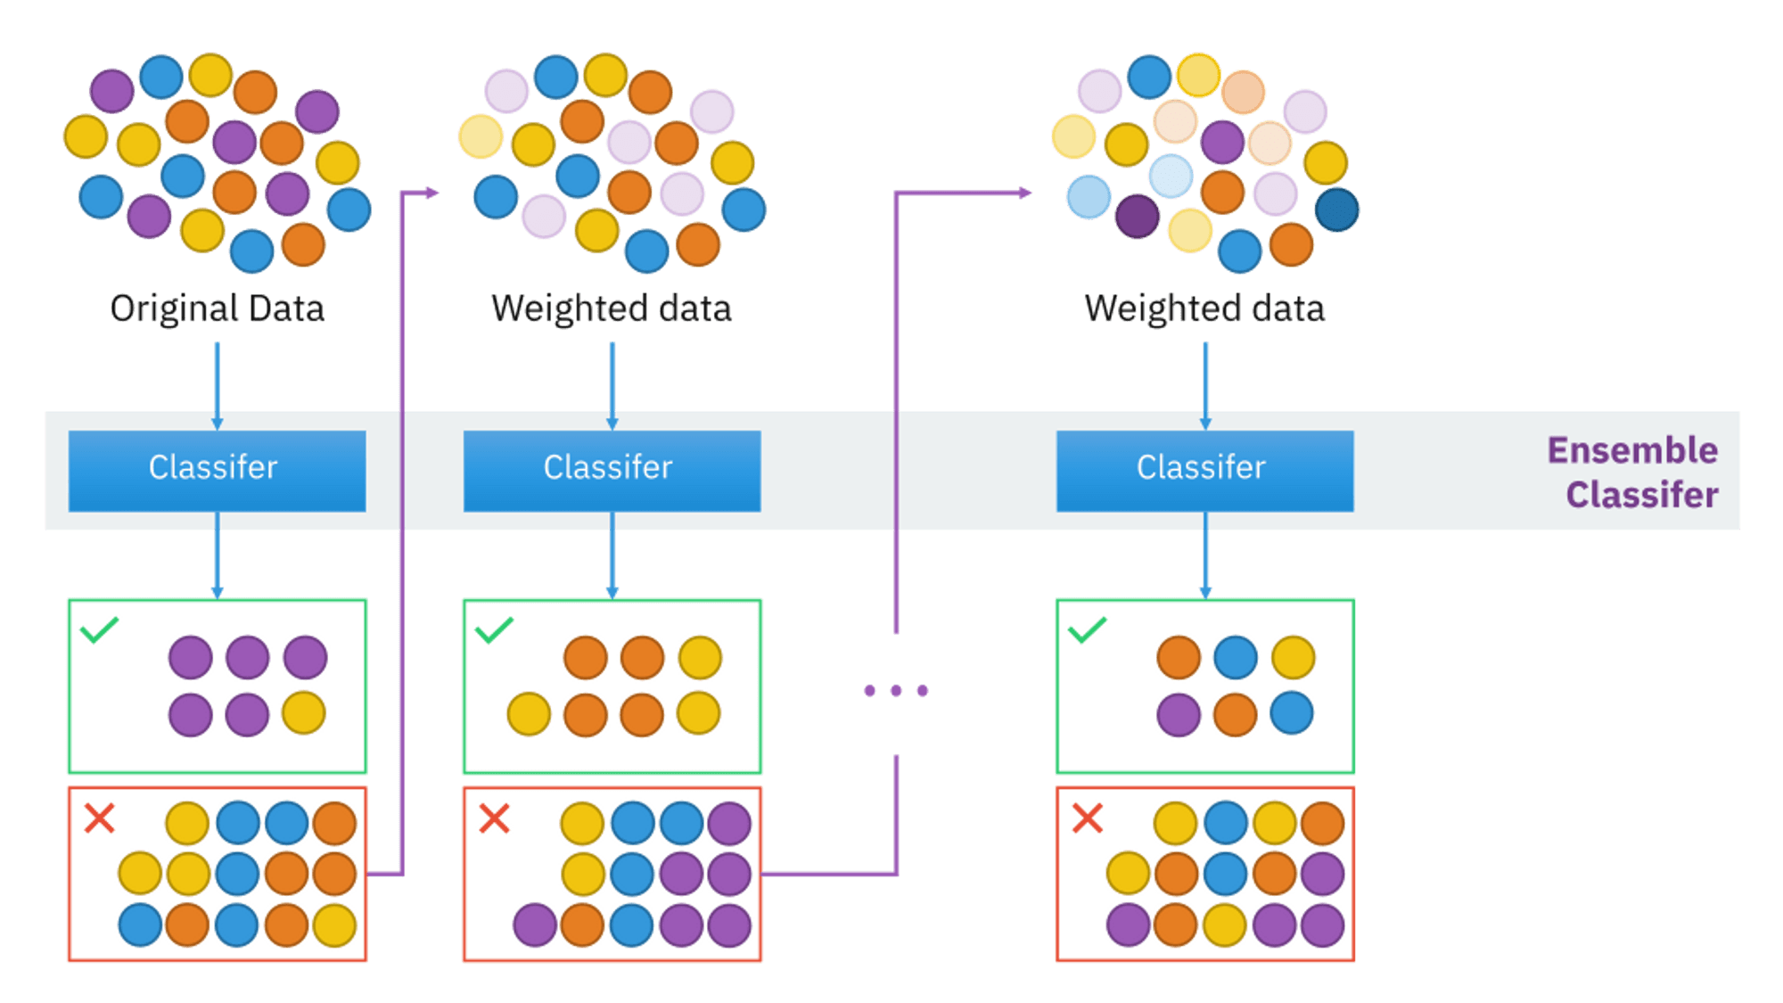

Above image was in Classifier image, so ada boost will work based on the error the error will carry until we get the correct predictions the weight also changes when the errors are boosting again.

**2. XGBoost**

XGBoost (Extreme Gradient Boosting) XGBoost is advance version of Gradient Boosting.

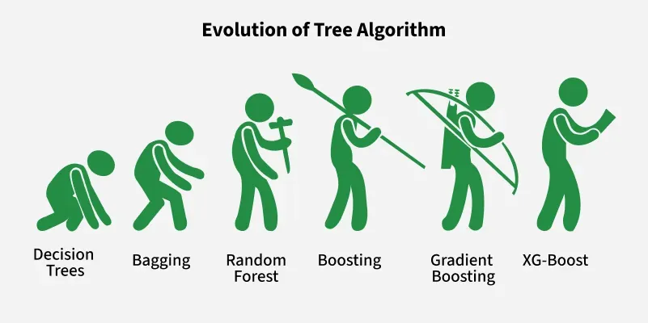

XGBoost builds decision trees sequentially, where each tree attempts to correct the errors made by the previous ones.

Each new tree tries to correct the errors made by the previous trees.

The final prediction is a sum of predictions from all the trees.

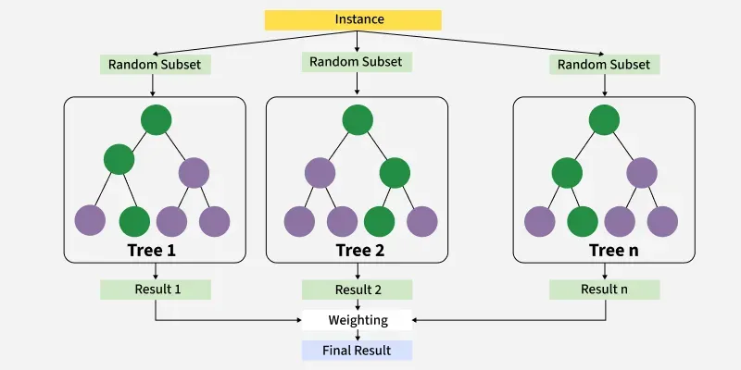

XGBoost uses advanced regularization techniques to prevent overfitting and improve model generalization.

**3. LGBoost**

LightGBM uses the gradient boosting technique, which combines multiple weak learners (decision trees) to create a strong predictive model.

* It builds a series of decision trees.
* Each new tree tries to correct the errors made by previous trees.
* Final prediction = sum of all trees.

Unlike traditional decision trees that grow level-wise, LightGBM grows trees leaf-wise, focusing on splitting the leaf with the highest potential for reducing loss. This can lead to faster convergence and better accuracy.

